**WHITEPAPER**

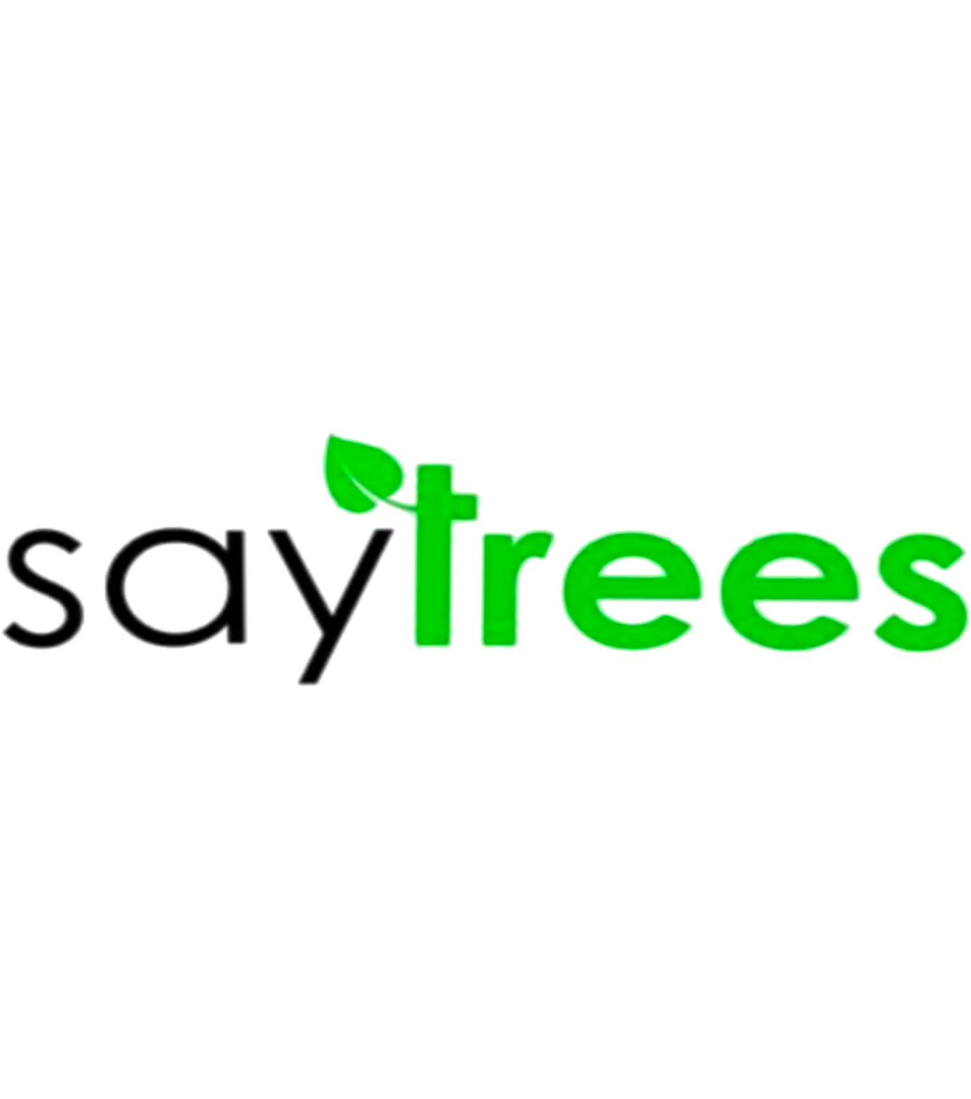

**“SAY FOR TREES”**

[**https://www.saytrees.**](https://www.saytrees.)**org**

**DISCLAIMER**

SAYTREES is not a licensed, unlicensed or exempted financial or payment service of any such kind and in any jurisdiction. Any terminology used in this whitepaper or on the Website is intended only as a basic reference, without any effective or legal meaning of the same terms in a regulated and/or financial environment. SAYTREES is a fully and completely decentralized and community driven project. The smart contract is open-source, permanent and non-modifiable in any way. SAYTREES is a utility token in any jurisdiction and cannot be considered as a security or otherwise a regulated token of any kind. This Whitepaper taken by itself is not a contract or a contractual agreement of any kind, is not an invitation, solicitation or offer to invest in SAYTREES or acquire or use its SAYTREES tokens in any way and with any expectation of profit in any form.

**TABLE OF CONTENT**

1. ABOUT
2. VISION
3. MISSION
4. SCALABLE BENEFITS
5. WHY SAYTREES?
6. WHY SAYTREES (NGO)
7. USE OF PROCEEDS
8. ROADMAP
9. TOKENOMICS
10. NGOs CERTIFICATION
11. TEAM

**ABOUT**

SAYTREES is a decentralized digital currency that aims to plant trees, save forests and assist the global fight against climatic change. Not only does each plant capture carbon and increase biodiversity but also ends hunger and poverty. Together with the support, we're on a mission to restore forests, create habitat for biodiversity, and make a positive social impact around the world.

SAYTREES is an eco-friendly cryptocurrency developing to lend a hand for maintaining the balance in the ecosystem so that each of us can lead a healthy quality of life.

Trees confront hunger, poverty, and environmental degradation by serving the people at the heart of our global food systems: farmers and their families. Around the world, landscapes are deteriorating and ecosystems are collapsing. The farming families that rely on the land to survive are trapped in cycles of hunger and poverty.

It is our responsibility towards our ecosystem to make efforts and harness our energy and resources to put back what we are taking away and help this world become a better place and be answerable to our future generations.

The number of trees in the world, according to a 2021 estimate, is 3.04 trillion, of which 1.39 trillion (46%) are in the tropics or sub-tropics, 0.61 trillion (20%) in the temperate zones, and 0.74 trillion (24%) in the coniferous boreal forests. The estimate is about eight times higher than previous estimates, and is based on tree densities measured on over 400,000 plots. It remains subject to a wide margin of error, not least because the samples are mainly from Europe and North America. The estimate suggests that about 15 billion trees are cut down annually and about 5 billion are planted. In the 12,000 years since the start of human agriculture, the number of trees worldwide has decreased by 46%.

SAYTREES is developed with an objective to provide a reliable cryptocurrency for both who are looking for investment and for doing transactions via Crypto. Our team is already in talks with various Corporations and Governments globally to get it approved as a tender for transactions. Gateways for crypto as a tender have already been opened up.

To make a progress as planned, we would join hands with our partners and supporters throughout the reforestation process, from planting saplings and taking care of young tress, through to their establishment. IN our quest, we intend to have various force rally alongside us – influencers across various channels, private investors as well as charitable organisations that will be chosen by the community as we mature in time.

**VISION**

Our vision is to promote continuous planting of trees and expansion of woodland across vulnerable communities to tackle the adverse effect of climatic change as a result of continuous indiscriminate deforestation.

Tree planting creates low-skill jobs, and trees provide benefits to current and future generations, have a direct impact on carbon reduction, restoring forests, improving wildlife habitats, and upgrading water catchment areas, and offer flowers, fruit fodder and fuel for local communities and all living creatures.

**MISSION**

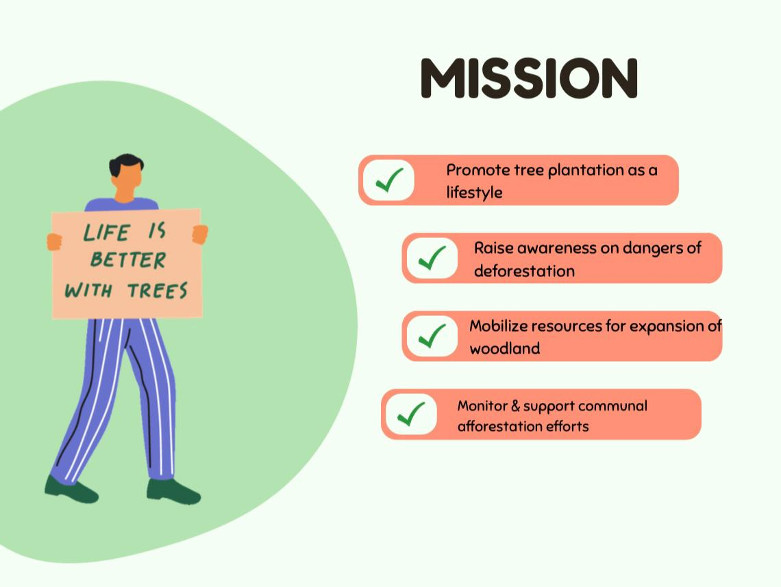

* To promote planting of trees as a lifestyle.
* To raise awareness on dangers of deforestation.
* To mobilize resources for expansion of woodland.
* To monitor and support communal afforestation efforts.

Our mission is to develop a community for sustainable land use so that they can grow vibrant economies, thriving food systems, and a healthier planet. Also, to make sure that tree improvement, long-term maintenance and end- use of the trees are monitored, traceable and authenticated. We want to make sure that tree improvement, long-term maintenance and end- use of the trees are monitored, traceable and authenticated. We are committed to reforesting our earth by planting One Tree for every 1000 tokens sold.

**SCALABLE BENEFITS THAT MAKE A DIFFERENCE**

* **CARBON CREDITS**- SAYTREES makes it easy to finance & purchase high quality, transparent carbon credits that conserve nature, remove atmospheric CO2 & send financial benefits to local communities.
* **IMPACT INVESTMENT PLATFORM**- It is the Blockchain market place for discovering & buying digital green bonds.
* **EDUCATION & AWARENESS**- It will encourage users to venture into nature and learn about how amazing trees are. Charities will also be involved where they can spread their messages to the userbase, educating them about various nature topics.

Besides the above scalable benefits of SAYTREES, the other benefits which tree provides are as follows:

* Oxygen provider
* Power investor
* Emission combater
* Natural Coolant
* Stress reducer
* Energy saver
* Stormwater filter
* Peacemaker

It is thus an open & permission LEDs blockchain built to meet the needs of NGOS, corporate ESG groups & purpose driven innovation.

**WHY SAYTREES?**

SAYTREES came out of the urge to assist in creating a specific, productive and sustainable action strategy towards afforestation of the extensively depleted vegetation and forest cover of communities within the most exposed regions.

Our observations led to biodiversity concerns. It was observed that the rate at which trees were being lumbered indiscriminately on a daily basis by locals and timber merchants, particularly to produce charcoal and furniture, there will be a serious distortion in the ecosystem and ecology of these exposed communities which may eventually end as an inexplicable environmental disaster.

These deforestation activities portend danger and needs to be countered with control strategies before it gets worse. It is on record that, almost 20% of global carbon emissions are caused by deforestation. It is also becoming obvious that there is already a disruption in the water cycle around this region.

This afforestation project, the coordinated planting and management of trees and the advocacy strategies to be deployed to curb and minimize the deliberate fall of trees for both domestic and export purposes will reduce global warming.

SAYTREES is a strategy to continuously encourage the replenishing of depleted woodland across communities by planting selected indigenous and adopted trees to protect these vulnerable communities from the immediate and future consequences of deforestation.

It is a painstaking strategy to salvage these communities from the dare environmental and even economic consequences of deforestation using the planting and management of trees as well as the expansion of forest resources by creating more woodland.

In simple words, we can say that SAYTREES will provide a complete picture of the NGOs’ internal processes—donors, recipients, and internal stakeholders.  With the help of SAYTREES, NGOs will be able to accept donations in the form of crypto funding.

**WHY NGOs?**

1. **SUPPORT TO FARMER COMMUNITIES** - The fruits of your tree will belong to the farmer who will be able to use them as a food resource or support for their income.

2**. CONTRIBUTE TO MAKE THE PLANET GREENER** - As your tree grows, it will absorb CO2, protect the soil and biodiversity.

3. **DEVELOPING A DIVERSE SKILL SET**- Established NGOs tends to have different skilled personnel who already experience to do their work.

4. **EFFICIENCY**- It is very important to collaborate with an NGO who is already working in the same direction with full efficiency.

5. **BEING CREATIVE AND RESPONSIVE**- Most NGOs have developed small size aids communication. They have a flexible workload and is ready for funding and sustainability risks besides applying for institutional funding. In other words, disruptions have a large impact on work which NGOs can face.

6. **BUILT TRUST AMONG DONORS**- NGOs have created a trust among its donors with the passage of time. It has provided transparency to its donors in all the fundraising operations. The donors have the confidence that their contributions are being used for the intended purposes.

**USE OF PROCEEDS**

A decentralized eco-friendly community where SAYTREES token holders earn passive rewards and support environment-centred projects that benefit local tree growers who are doing the hard work in restoring our ecosystem.

Newly planted and mature trees worldwide will be geo-tagged by 2025, minted and stored in the blockchain. Those trees will be minted as NFTs and can be traded for SAYTREES token in its adoption market.

Our mission is to make sure that tree improvement, long-term maintenance and end- use of the trees are monitored, traceable and authenticated.

We also want to make sure that our technology creates environmental and economic value and can serve as a reliable source of income for millions of smallholder tree growers worldwide.

Revenue generated from planting of trees will be partially used for further plantation and other part will be added in the liquidity increasing the strength of the project which would ultimately benefit our investors.

**ROADMAP**

**PHASE-1**

- Forming communities on various social media platforms to establish a platform where people across the globe come together and contribute to this global cause.

-Joining hands with existing NGOs who are already doing their best to save the environment.

- Naming this project "SAYTREES” is because blockchain technology can bring a substantial growth to reforestation and can bring an evolution to the nature lovers who can be pushed to grow more and more trees.

-Tag line- “

SAY FOR TREES”

clearly stating the intentions to connect Bitcoin technology with reforestation.

- Successfully launched our website

**PHASE-2**

-Successfully verified our contract code on BSC scan with 'SAYTREES' ticker.

-Completed our Whitepaper putting down our thoughts and aspirations in a constructive way.

-Registered on all related social media platforms to expand our community.

-Sharing thoughts and efforts with an NGO “ONE TREE PLANTED” for planting trees to make our planet Earth clean and green.

**PHASE -3**

- Registration on Coingecko and CoinMarketCap.

- Launch on Pancake swap and Bakery swap.

- Listing on Multiple Exchanges

**PHASE-4**

- We will introduce our NFT's for sale solely for charity.

- We will join our hands with more NGOs across the world to move a step forward towards our goal.

- We aim to create one of the biggest and most loyal community, working together for a cause.

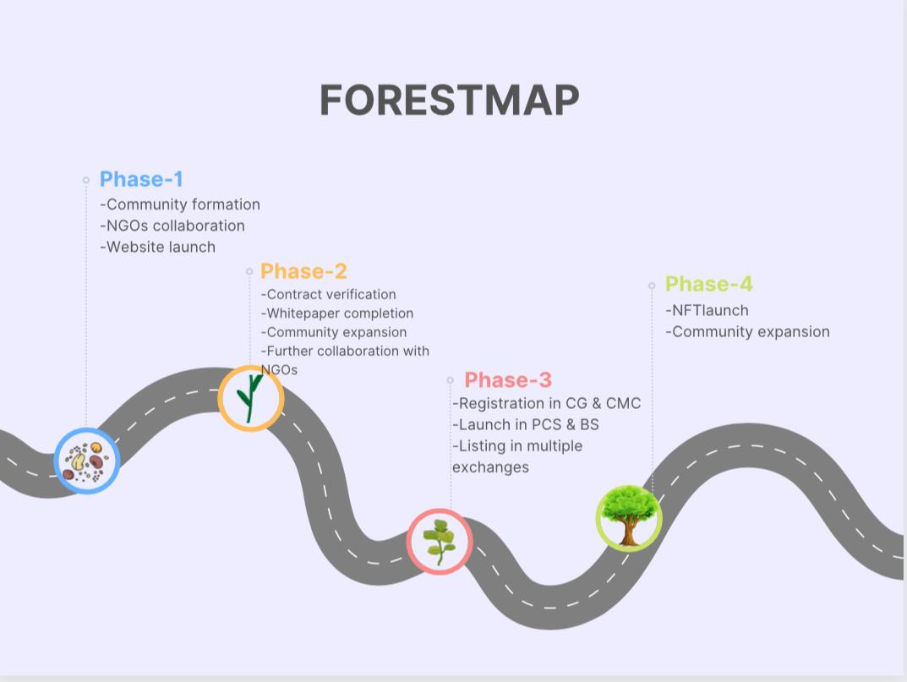

**TOKENOMICS**

* **RESERVES**

8% of the total supply will be kept as reserves which can be treated as emergency funds for any further development of the project.

* **PUBLIC SALE**

48% of the supply is kept for public sale which will be unlocked in 4 phases

-14% of total supply will be unlocked at the initial launch.

-10% of the total supply will be unlocked in October 2023

-10% of the total supply will be unlocked in January 2024

-10% of the total supply will be unlocked in April 2024

* **PROJECT DEVELOPEMENT**

This pool contains 12% funds for the development of this project.

* **FOUNDERS**

6% of the total supply will be kept as founders fund.

* **MARKETING (Airdrop/Rewards)**

It is 16% supply which will be used for marketing activities like staffing, project operations, partnerships, consulting, general expenses and promoting the project. This percentage has been determined based on the longevity of this project to ensure it can be funded long term.

* **CHARITY**

10% of the supply will be donated as charity to various NGO’s that can lend a hand in planting for our posterity.

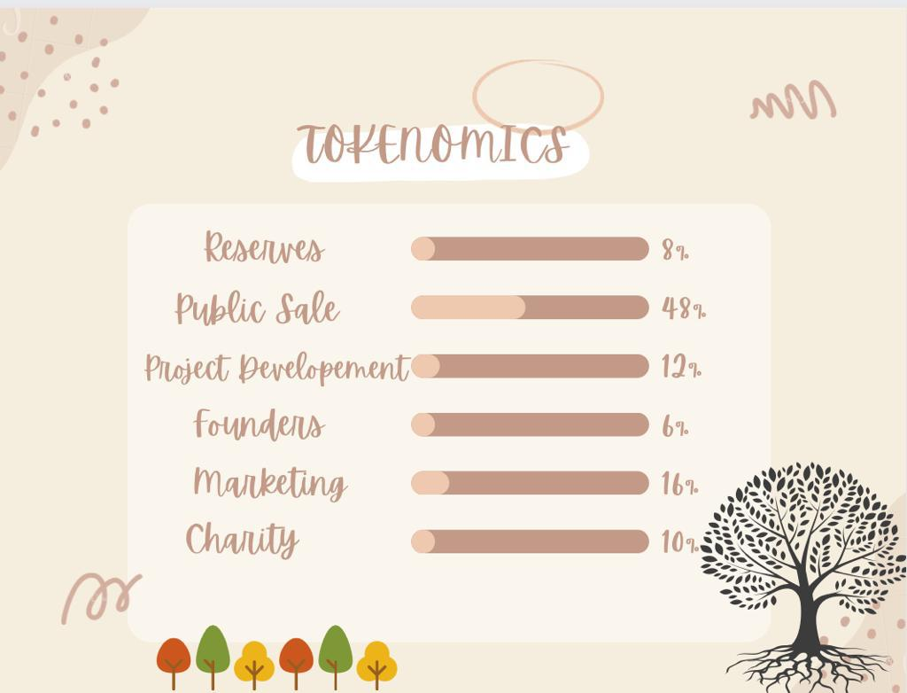

**CASE** **STUDY**

* **WWF (** <http://join.wwfindia.org/donation> **)**

WWF applied the concept of NFT rarity to endangered species and issued as many NFT as there are animals left. This not only helps raise money to protect these endangered species but also communicates the sad truth that there are a limited number of animals left.

* **ORICA (** <http://www.orica.com> **)**

This is a NFT marketplace. Their “mission is to accelerate wealth equality through digital assets”. They do this by making it easy for artists to raise money through NFT sales and give the proceeds to charities.

* **ONE TREE PLANTED** ( <http://onetreeplanted.org> )

One Tree Planted believes that cryptocurrency and bitcoin donations are an efficient way to support their NGO, given that while one’s crypto donation is tax-deductible and at the same time a non-taxable event: one does not owe capital gains tax on the appreciated amount.

* **SANKALP TARU** ( <http://sankalptatu.org> )

Sankalp Taru has always pioneered through its various creative inventions and has brought technology closer to the cause by accepting the donations in cryptocurrency. Every planted tree in the digital forest bears a unique data and a placeholder to cross-verify the details shared with the donors.

**TEAM**

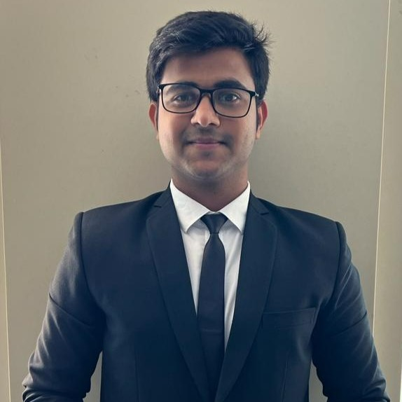

**1.KRUTIK MEHTA (Chief Executive Officer)**

[**https://www.linkedin.com/in/krutik-mehta/**](https://www.linkedin.com/in/krutik-mehta/)

**-Pursued my Post Graduation from NMIMS Bangalore**

**-keen learner and passionate for tree plantation**

**-Associated with many other NGOs to make the world a better place to live.**

**-Cofounded SAYTREES with an aim to combine the potential of blockchain technology with a good cause of planting trees as a social responsibility**

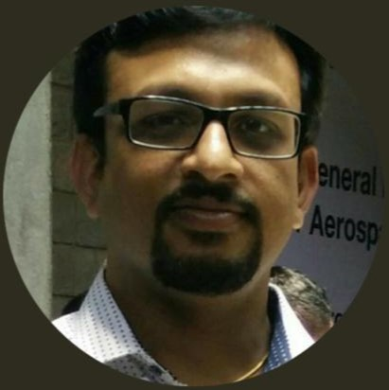

**2. MAHIDHAR REDDY S (Head at Rural Programmes)**

[**https://www.linkdin.com/in/mahidhar-reddy-s-47591274**](https://www.linkdin.com/in/mahidhar-reddy-s-47591274)

**-National Institute of Rural Development & Panchayat Raj**

**-Head at Rural Programmes at Say Trees**

**-Also started working for SAYTREES with an ambition to give back to nature at most what we are taking from it.**



**3.SMRITI JOANNE BOSCO (Manager Corporate Communication)**

[**https://www.linkdin.com/in/smriti-joanne-bosco-35720142**](https://www.linkdin.com/in/smriti-joanne-bosco-35720142)

**-Graduate from Monash University, Australia**

**-Major in Sociology and Psychology**

**-A content writer by choice**

**-Passionate about writing and poetry**

**-Working with SAYTREES truly shows my love and social responsibility for green environment.**

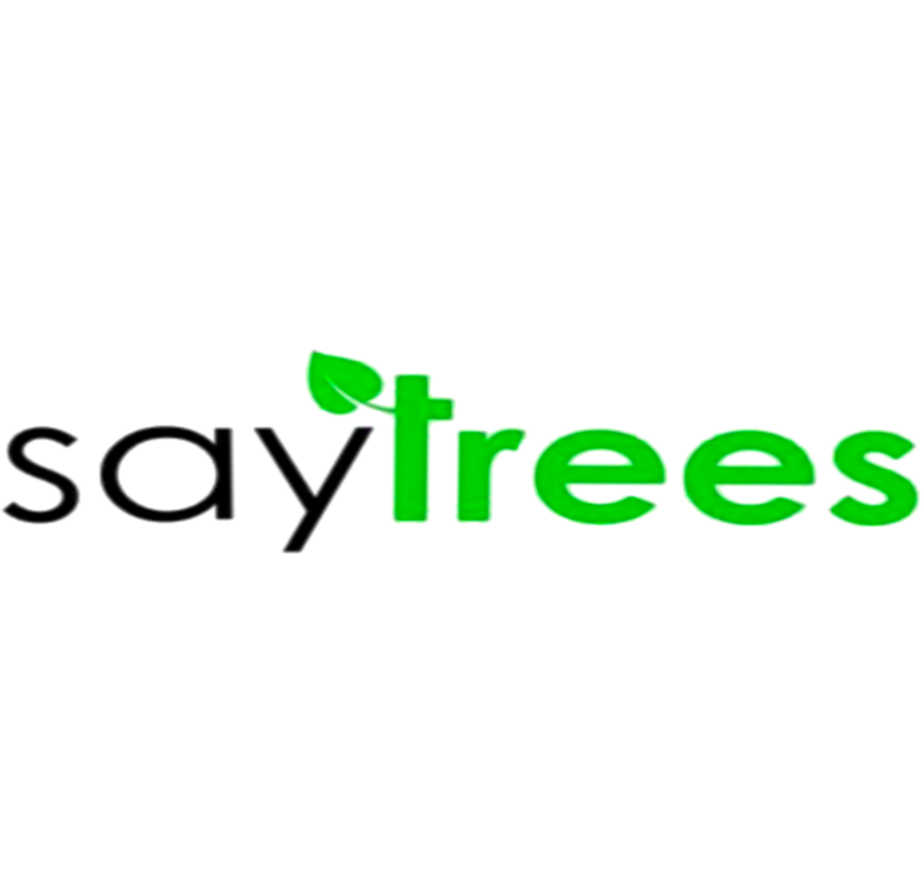

SAY FOR TREES 🎄

[**www.saytrees.**](http://www.saytrees.)**org**